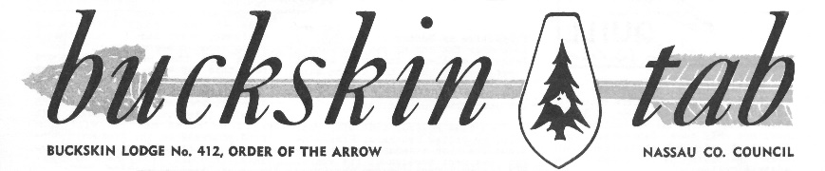
7829 Newington Woods Drive
Springfield, VA 22153-2236
e-mail: lodestar@cox.net

I’m happy to share with you a collection of Buckskin Tab issues from fifty years ago. Those pages tell the story of Buckskin Lodge, its leaders, and the camps it supported during a period of unprecedented popularity and growth.
Back in those days, Buckskin Lodge dues were only $1 a year, tickets to the annual Buckskin Banquet cost only $4, and meals for an entire service weekend at camp were only $2.50. The 9-day trip to attend the 50th Anniversary National Order of the Arrow Conference cost only $55: $32 for room and board at Indiana University, and $23 for round-trip bus transportation.
Lodge membership crossed the 2,200 mark in 1968. Attendance at the Buckskin Banquet grew from 791 in 1963 to over 1,400 in 1969. The Onteora service weekend in September 1964 attracted 542 Brothers, including 152 inducted that weekend. The Wauwepex service weekend drew 523, including 228 new inductees.
Banquet speakers included everyone from a bank manager, to a major league baseball pitcher, to a national newscaster, to a network radio vice president, to an international diplomat. The speaker one year was a senior military officer; little did we know that our speaker’s son would be shot down over Southeast Asia ten months later, spend five and a half years as a prisoner of war, and later rise to national prominence as a U.S. Senator and candidate for President.
Perhaps most important, these pages chronicle some times and places that meant a lot to us as we were growing up, some leaders who inspired us, and some friends who helped us through it all. I hope they awaken some good memories and cause you to reach out to some of these people while you still can.
If you know of anybody who can help fill in the few gaps, I would really appreciate the opportunity to borrow hard copies and promise to return them:
- Volume 13: Number 2 (Dec 1963) is a poor copy; also, I don’t have anything after Number 3 (Feb 1964)
- Volume 20: Number 8 (May 1971) is missing
- Volume 21: I don’t have anything after Number 8; there should at least have been a Number 9 (May 1972)
- And, of course, I’d be happy to expand the collection with anything before Jun 1963 or after Apr 1972
Thanks again, and I do hope to hear from you.
Firm Bound in Brotherhood,

MIKE KELLY
PS – I have also included some issues of the National Order of the Arrow Bulletin from this era. You will see more than a few items concerning Buckskin Lodge and its members.
Rev 01/2015

