The Onteora Alumni Association

Announces
The 2nd Annual Fall Weekend

And Business Meeting
September 19, 20 and 21, 2003

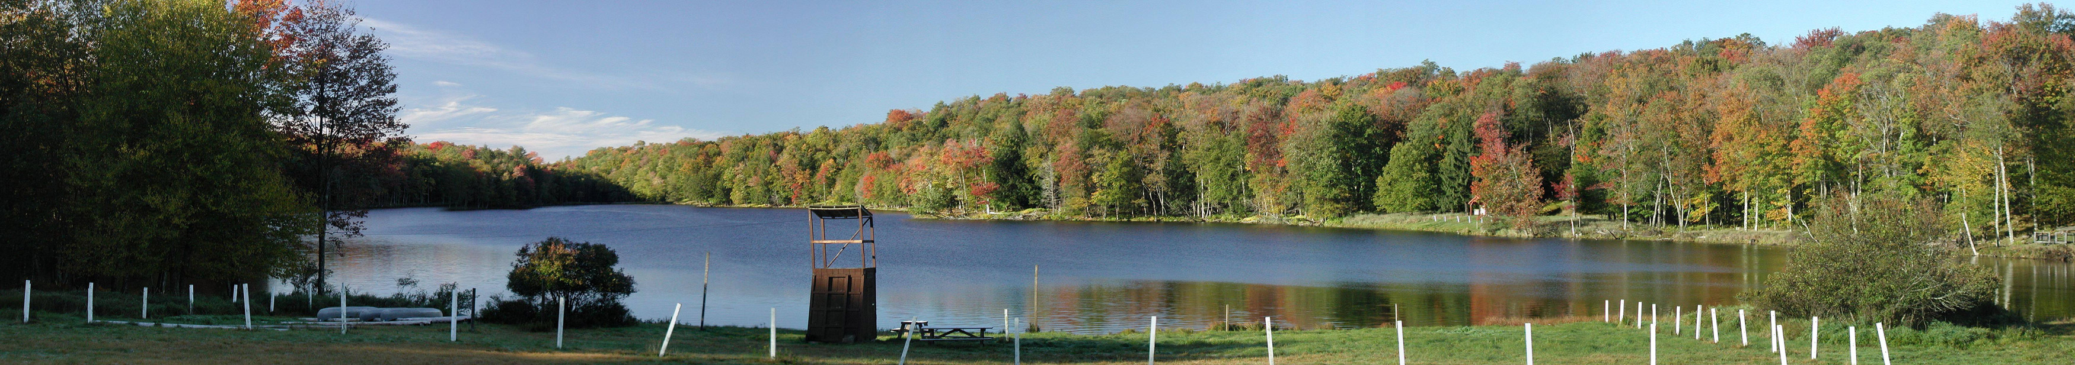
----------------------------------------------------cut here-------------------------------------------------------
The 2nd Annual OAA Fall Weekend will be held at camp – hang out, camp out, and participate in the near famous Auction. Breakfast, lunch, and dinner will be served on Saturday, and a light breakfast on Sunday (Dinner on your own Friday night). Of course, we will have a campfire after the annual Business Meeting.
Let’s go to camp. I am bringing ______ person(s) at $ 15.00 per person, so I have enclosed $ _______
However, if I forgot to send this in by the registration deadline of September 1, 2003, I will still bring ______ person(s) at $ 20.00 per person, so there is $ _______ enclosed.
I will also bring the enclosed Class 1 medical form for all participants under 40 years old, and the enclosed Class 3 medical for all participants 40 years old plus.
Name ________________________________________________
Address ________________________________________________
City, State Zip ________________________________________________
E-Mail ________________________________________________
Return this information with your payment to

Onteora Alumni Association

Attention: 2003 Fall Weekend
544 Broadway
Massapequa, NY 11758

