2001 Hiking Trail Guide

July 25, 2001

As in the past two years, we have been working hard to re-establish and improve on the original Onteora hiking trails. Some of the trails go onto what is now part of the Catskill Forest Preserve. We are permitted access, but cannot mark the portions of the trails, which reside in the preserve. These areas will be identified in this hiking guide. Observant hikers should be able to notice old trail markers that still exist throughout the trail system.

New for 2001 is a trail extension to the Caves (Orange Trail). This takes you to the northeast end of Rattle Hill. From here the trail turns south and picks up on an old logging road. This new extension will bring you down to the Al Nassau shelter. Take a minute at the shelter, where you will find a box mounted on the wall with a guest logbook. All the members of your hike are welcome to make an entry into the book. After leaving the shelter you will come to a field where the remains of an old logging community can be found. Walking the perimeter of the field will bring you by some old foundations, OSR outpost camps and fireplaces. You will next go by the Marshall Lesser Lean-tos, which are available to troops for outpost camping. Continuing on the road will bring you by a beaver lodge with three dams and the old Catholic chapel before exiting at the Trading Post.

All of the Onteora hiking trails now start at the hiking stump, which is located by the north end of the Long House Dining Hall. (This is in the vicinity of the flagpole.) OSR presently has four marked trails as follows:

The Red Trail makes a circle around a large portion of the camp. Sections of this trail can be found in numerous locations throughout the camp. The entire trail is 10 miles.

The Orange Trail heads north to the caves, then turns south to the Al Nassau shelter, old logging camp, Marshall Lesser Lentos, and beaver dams. Trail is 8 miles.

The Blue Trail heads north up Old Hunter Road to Tom Quick Pond, Beaver Kill and Lew Beach.

The Yellow Trail parallels the Blue trail to Tom Quick Pond. It next turns onto hiking and snowmobile trails to Mongaup Pond where there is public fishing and swimming. The trail then follows the Old Hunter Road, a historic route, which passes the State Fish Hatchery and an old cemetery.

Since the Onteora trails are not used most of the year, they have a tendency to become overgrown. We ask everyone’s assistance in helping to keep the trails open by clearing downed trees and removing any litter you may find. Troops looking to perform a service project by helping to improve the OSR trails should contact Steve Gershowitz (516-826-0577). Enjoy your hike and all that OSR has to offer.

NOTIFICATION AND SUPERVISION

Before leaving camp on the Blue, Orange, or Yellow Trails, you must present a roster and hike plan with estimated time of return to the administration office. There must also be a 21-year-old leader present on all hikes that leave OSR.

The Venture Director will provide maps and directions to your unit upon request. When available, program staff can be scheduled to accompany patrols or troops. Please contact your program commissioner or Venture staff for more details.

Many of the trails cross the New York State Catskill Forest Preserve and private land. New York State regulations governing the use of the State Forest Preserve must be followed. Nassau County Council has also retained hiking rights on former camp property, which is now state owned. This land is posted, please stay on the trail!

WILDLIFE ON THE TRAIL

Onteora and the Catskill Forest Preserve are blessed with a wide variety of wild creatures. Animals may be dangerous if cornered or threatened. Under no circumstances should anyone touch or disturb snakes or other animals.

If you have any problems, please see your program commissioner. Happy Hiking!

TRAIL GUIDE

This trail guide is presently being maintained and updated by Steve Gershowitz (516) 826-0577. If you have any additional information, questions or corrections please contact me. Thank you. steve2nd@yahoo.com
RED TRAIL

This trail now goes primary around the perimeter of the Onteora property. Most of the trail runs through the woods, coming out in only a few locations. The trail follows along many different topographical features including logging roads, wooded areas, over streams and climbs a ravine. It is a loop, with the trail starting and ending at the "Hiking Stump." At the present time some parts of this trail are not clearly marked and go onto state land. This is a more challenging hike for those with trail experience.

Points of Interest -- Dan Beard Program Shelter; Joseph Shields Memorial Campfire Ring; Orchard Lake Dam; Blauvelt Health Center; Al Nassau Program Area; Council House Storage Facility; Haunted Forest

START -- The trail starts at the "Hiking Stump" at the Long House Dining Facility. From there you will go to the West Side of the Long House, where the trail joins the Tuscarora trail. The Long House was built in a snowstorm in the late fall of 1958. This food service facility serves the entire camp, although it originally served Tribes Camp.

ECOLOGY TRAIL – The Tuscarora trail splits off at the start of the Ecology trail. This area runs adjacent to a swap. There are numerous information plaques, which have been put out by the Nature Lodge.

TRIBES LOOP ROAD – The Ecology trail ends at the south end of the loop road just east of a stream. You will go west (right) onto the road. The road will turn to the left. Shortly after the turn the Red trail will turn west (left) and go up hill. The trail will turn north and parallel the camp road behind some of the sites.

SHOOTING SPORTS ROAD – The trail will cross the road to shooting sports. Be careful not to wonder onto the range. From here you will go through many different types of forests. You will also go through a rock outcrop and will need to squeeze through a crack in the rock.

OLD HUNTER ROAD – The trail comes out onto the road, which is an old logging road. You will head south (right) and in a short time will come to an intersection. Continue straight and you will end up at Council House.

COUNCIL HOUSE – This was once the main dinning hall for the Chiefs camp. From 1960 through 1977, Onteora Scout Reservation operated two camps, Tribes Camp and Chiefs Camp. All campsites in Chiefs Camp are named after Native American leaders, such as Little Calf, Hiawatha, and Black Beaver. It was opened in 1960 and in 1976 became the craft lodge. Today it is used for storage. An official United States benchmark (Elevation 2186 feet above sea level) is located at the southwest side of the building. See if you can locate it. The trail continues on a road in the southwest corner of the field.

THROUGH THE WOODS – A short way down the road the trail turns northeast (left) just after an old latrine. This is a new sector of the Red Trail. Care must be used in this area, which contains rock ledges and significant changes in elevation. This area was logged in the late 1970's as part of an organized timber management program. The trail will come out near Marshall Lesser campsite and the Al Nassau Program Area. The start of the trail is behind the latrine for the old Corn Planter campsite. You will head east and go up and over the hill. The Marshall Lesser campsite is at the bottom of the other side. This will be about a 0.7 mile trail.

MARSHALL LESSER AND AL NASSAU PROGRAM AREA -- This area was a logging area for the Reserif Lumber Company in the late 19th century. What is now the Al Nassau area of the camp was then a small town consisting of five houses, a logging camp, and a mill. The foundations of the houses and the mill can still be seen in the field. During the "Roaring 1920's" the area was the property of the New York Trout and Skeet Club. Many people came to the area from New York City to fish and vacation. The remnants of the club's fireplace can be seen at the eastern edges of the field, and can be used to cook a hiking lunch. The field was also used as a skeet range.

This area was designated as the third camp area for the reservation called Buckskin Camp. This section of Onteora was used for the Buckskin Camp Program, where troops cooked all three meals using the patrol cooking method. The trail runs across the open field and turns north (left) uphill onto an old logging road.

ALDER LAKE TRAIL – The Red trail will now run with the old Alder Lake trail. This is marked with white / red marking. The old logging road continues uphill then intersects with another logging road. You will turn right. Continue uphill. You will enter State Land.

LEAVE ALDER LAKE TRAIL -- The trail will exit the road on the right and will twist through some rock outcrops. It will come out on another road. You need to go right, around a large down tree.

SWAMP – The road will continue downhill. You will pass a swamp on your left. It will then turn right into the woods.

OLD BRIDGE CROSSING – The remains of an old wooden bridge crossing a ravine exist. Go past the old bridge and cross. DO NOT CROSS ON THE OLD BRIDGE. The trail will bring you through some nice forest areas and past a large downed tree. You will then come to some areas, which have been logged, be careful.

HEALTH LODGE – The trail comes out at the rear of the Health Lodge. Go out to the main road.

PARADE FIELD -- The Red Trail crosses the main parade field. When the New York Trout Club owned the camp. The club's manor house was located to the North of the existing flagpole. The site of the Tuttle House, occupied by Leland Tuttle, who was the club's caretaker, was located to the Northeast. In the 1960's and 1970's, reservation retreats on Visitors' Day were held here, accompanied by a salute from a black powder musket. Order of the Arrow call-out were also held here. In early morning, deer can be found here, feeding on apples from old trees. Follow the trail around the left side of the field. The trail will go into the woods on the far side of the field opposite the Health Lodge.

OTHER SIDE OF ORCHARD LAKE -- The trail follows along the East Side of the lake. This is an excellent wildlife area. If you walk quietly and slowly, you may see some deer, beaver, chipmunks, or maybe a raccoon. The trial continues around to the Orchard Lake Dam.

ORCHARD LAKE DAM -- (Elevation -- 2061 feet above sea level) DO NOT CROSS OVER THE DAM! This old stone dam and its machinery ' controls the level of water in the lake and is regulated by the camp ranger to insure adequate waters for swimming and boating as well as draining of the top water from time to time to keep the lake clean. This becomes quite difficult in late summer, due to little rain, and must be carefully controlled. The trail crosses Sprague Brook below the dam and turns right (north) at the old camp road. If you were to go south (left) for a short distance, (0.6 miles) you would come to the original camp entrance.

OLD CAMP ROAD -- The Red Trail follows the old camp road north, which was build by the New York Trout and Skeet Club to provide access to the club's manor house. Follow the road to the old Tribes Camp waterfront area. At this point, the Red Trail turns left (west) up "Cardiac Hill" to the Joseph Shields Memorial Ring.

"CARDIAC HILL" -- This trail goes up "Cardiac Hill' through the Joseph Shields Memorial Campfire Ring, which was used for Order of the Arrow ceremonies from 1977 to 1983. The trail continues up the hill to the lower part of the loop road. At the road, turn right (north) and follow the road to Keuka Campsite.

TRAIL END -- At Keuka Campsite, turn left (west) off the road and continues uphill to the Long House Dining Facility parade field and to the "Hiking Stump."

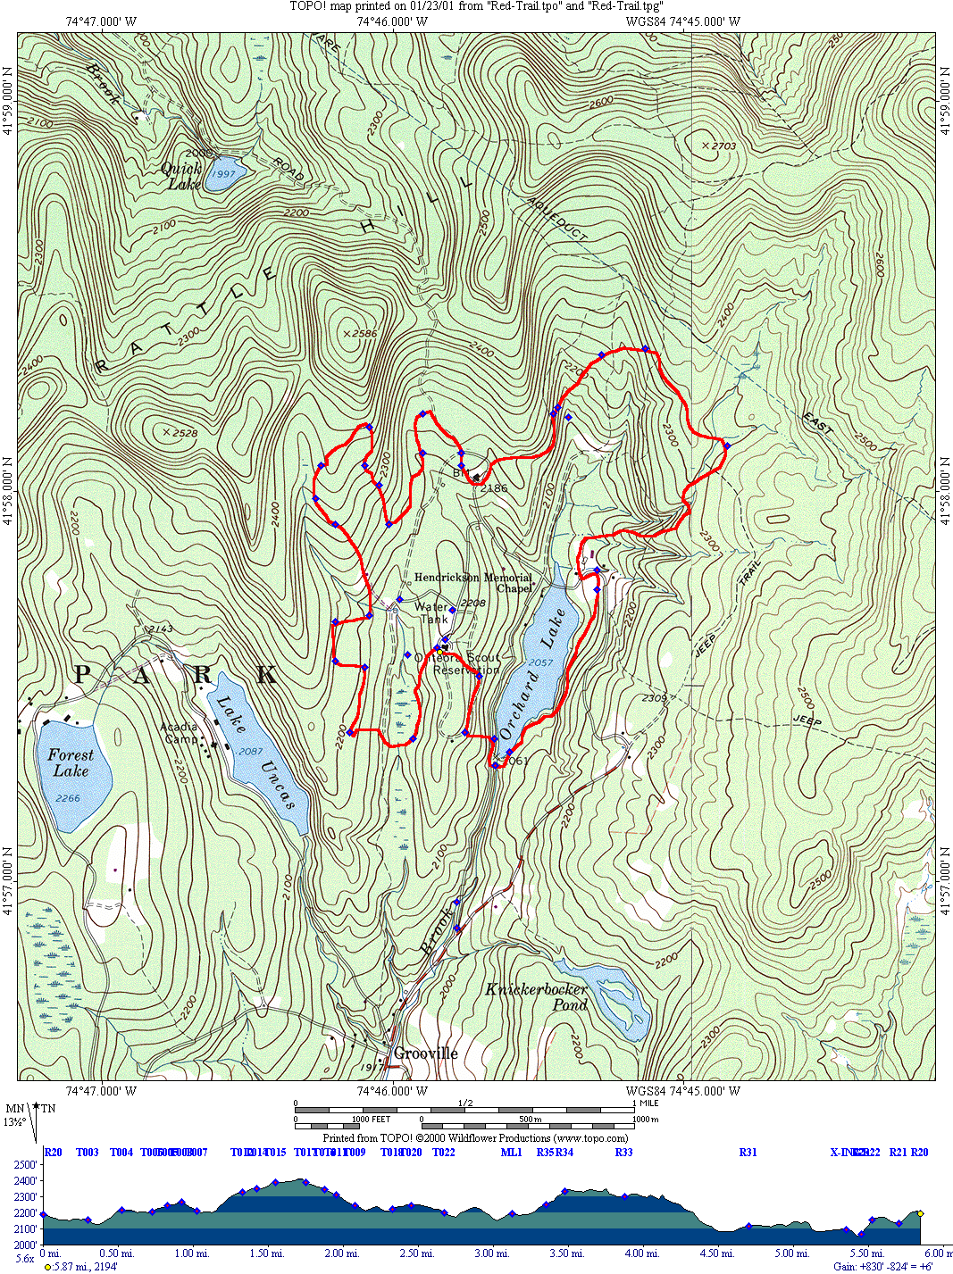
ORANGE TRAIL
(CAVE HIKE)

BRING THE FOLLOWING -- Flashlights

POINTS OF INTEREST -- U.S. Geology Survey Bench Marker, Rattle Hill, Blue Trail, Rock Formations, Smaller and Larger Caves

0.0 miles: START -- From the Long House Parade Field at the "Hiking Stump, take the main road past James E. West Program Shelter and the Buckskin Craft lodge (north). The trail turns left at the bend in the main road to old Chiefs Camp. Follow the trail past the Council House Storage Facility, which served as a dining hall from 1962 through 1975. A United States Geology Survey Bench Marker is located on the southwest side of the building. Follow the trail past the storage facility to the old Lynx Loop Road.

0.9 miles: OLD HUNTER ROAD -- The Orange Trail and the Blue Trail meet at the old Lynx Loop Road, and proceeds north up the Old Hunter Road. This Road was built by John Hunter in 1815 and opened the area for settlement. It is said that prior to being a road, it was an Indian trail, which ran from the Delaware to the Hudson Rivers. The Orange Trail and Blue Trail will run together to the top of Rattle Hill.

1.8 miles: RATTLE HILL – The trails then emerge at the top of Rattle Hill (Elevation 2,400 feet above sea level). The Blue Trail continues north to Beaver Kill. The Orange Trail turns to the right (east) towards the caves. After a while you will see a large rock formation in front of you.

2.5 miles: THE TOP OF THE CLIFF -- The trail turns to the right and you climb to the top of the cliff. The trail will reverse direction on the opposite side of the cliff. Soon you will see the first cave.

CAVES -- All other small caves you must find by yourself. This is all part of the adventure of finding caves. Most small caves are between the top and the bottom of the rock hill as you continue on the trail.

ON THE TOP OF THE HILL -- Continue on trail along cliff with small cave on right. Finally the cliff will disappear on your right.

LOGGING ROAD -- Soon you will come to an old logging road. Make a right and follow the road for a very short distance. You will come to another logging road that goes off to the right. Follow this new road.

AL NASSAU SHELTER – After a short time, you will be back on the OSR. At this point you will see trail markers again. At times the road is hard to follow, but the trail is well marked. You will eventually end up at the Al Nassau shelter. Take a minute at the shelter, where you will find a box mounted on the wall with a guest logbook. All the members of your hike are welcome to make an entry into the book.

OLD LOGGING CAMP -- After leaving the shelter you will come to a field on your left where the remains of an old logging community can be found. Walking the perimeter of the field will bring you by some old foundations, OSR outpost camps and fireplaces.

MARSHALL LESSER LEAN-TOS – Following the road around to the right will bring you by the Marshall Lesser Lean-tos, which are available to troops for outpost camping.

BEAVER LODGE -- Continuing on the road will bring you by a beaver lodge with three dams and the old Catholic chapel.

TRADING POST – The logging road ends at the intersection of the camp main road and the trading post. After stopping at the Trading Post for refreshments, go back to the road and cross over the bridge so you can go around Orchard Lake. At this point you will be following the red trail back to the Long House.

NOTE -- This hike REQUIRES adult and/or camp staff leadership!

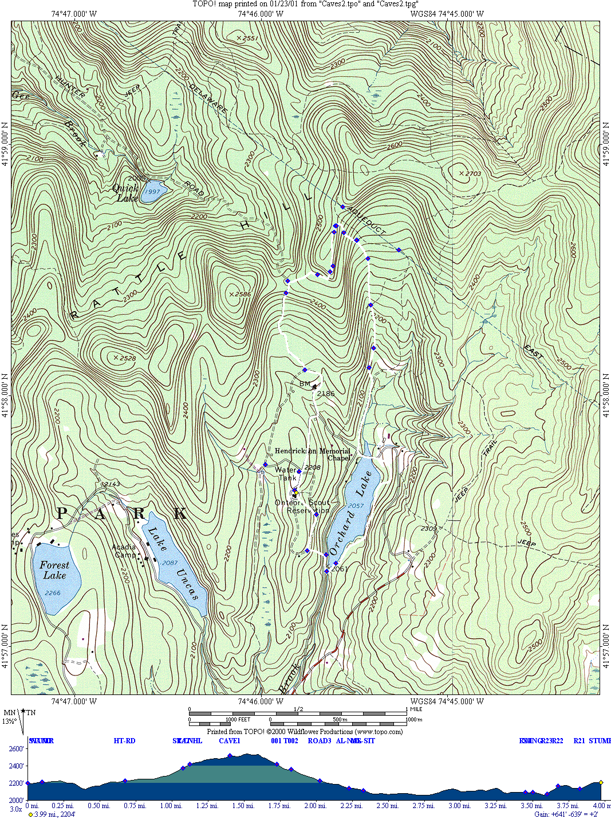

BLUE TRAIL

POINTS OF INTEREST -- Side hike to caves, Tom Quick's Pond, Lew Beach covered bridge, Beaver Kill State Park Campsite, town of Lew Beach.

The Blue Trail may be taken to either Beaver Kill or Lew Beach by turning right at Beaver Kill Road for Lew Beach or left there for Beaver Kill. Because this trail goes off camp property, a 21-year-old is required to accompany the group of hikers.

0.0 miles: START -- The trail starts at the Long House Dining Facility and the "Hiking Stump." Go north on the main road to the camp water tank and turn left (west). Follow the road to the old Lynx Loop Road and turn right (north). Follow the trail around the Lynx Loop to Old Hunter Road. Turn left on Old Hunter Road and follow the trail up Rattle Hill. The Orange Trail meets the Blue Trail on Old Hunter Road and follows it to the top of Rattle Hill.

1.1 miles: RATTLE HILL -- At the top of Rattle Hill (Elevation -- 2,400 feet above sea level) is the intersection of the Orange Trail to the caves. In the early days of Onteora Scout Reservation, an outpost lean-to was constructed near here to provide an area for patrol camping.

1.9 miles: TOM QUICK'S POND -- Continue straight ahead on Old Hunter Road for 1.1 miles from the top of Rattle Hill, you will see Tom Quick's Pond on your left. Tom Quick, the man who logged most of the country around here and was of great assistance in blazing many of our original trails, constructed this. You are now on the Catskill Forest Preserve. All State Regulations govern use of the preserve. Stay off of the dam. It is broken and beavers have built up the area around it. If you look off the left of the dam, you can see two areas where the beavers have built lodges. Stay off the beaver lodges, they are their home and we do not want them damaged.

3.5 miles: BEAVER KILL ROAD -- Further down Old Hunter Road it comes out on a paved road, which runs left to Beaver Kill and right to Lew Beach.

BEAVER KILL -- Go left at Beaver Kill Road for about a hundred yards before turning right into the woods. You will shortly come out into a large meadow. Finally, Beaver Kill Road forks at a sign indicating Beaver Kill State Park. With Beaver Kill Road going to the left and the State Park to the right, continue down the road for about a quarter mile over the covered bridge to the campsite.

3.8 miles: Cemetery – Turn right onto Beaver Kill Road. The Cemetery will be a short distance on the right. There are many old tombstones dating back to the 1850s.

4.0 miles: LEW BEACH -- There is a gas station, gift shop and grocery store all rolled up into one. Be sure to check it out. To return to camp following the Blue Trail along the route used previously.

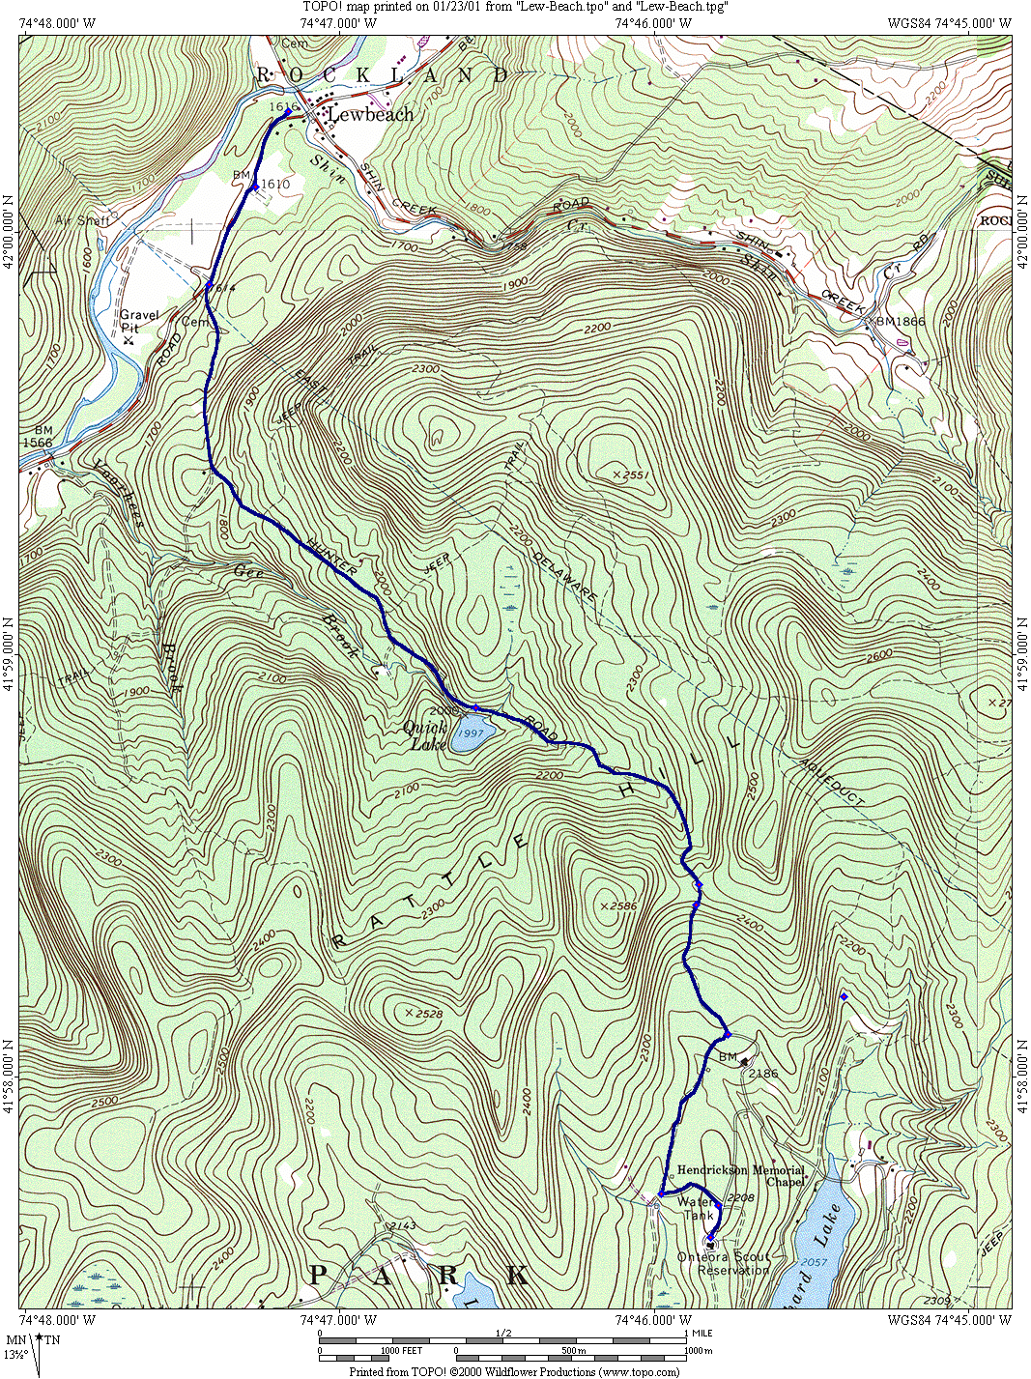

YELLOW TRAIL

POINTS OF INTEREST -- Mongaup Pond State Campsite (side hike), Mongaup Creek Waterfalls (side hike), Catskill State Fish Hatchery, Old Cemetery

Distance | Description
0.00 | The trail starts at the "Hiking Stump" by the Long House Dining Facility
0.10 | Turn left at the Water Tower
0.30 | Turn right onto the old Lynx Loop Road
0.80 | Turn left onto Old Hunter Road
1.10 | State Line
1.20 | Top of Rattle Hill
2.10 | Tom Quick’s Pond
2.15 | Start of Snowmobile trail at North end of Quick Pond. Turn right (Houses with telephones are located to the left of this intersection.)
7.15 | Intersection for Mongaup Pond loop. This is a state park, which has fishing, swimming and access to hiking trails. Go right
7.95 | Traces crosses Mongaup Pond Road. Turn right onto the Road. (Telephones are located by the south entrance to Mongaup Pond.)
8.45 | Road to Frick Pond – For a side trip, if you take the left fork in the road, it will bring you to Frick Pond. (You will be entering the fork from the right side.) From the parking lot the pond is about a 0.5 mile walk. This is a state hiking trail around the pond, and access to other trails (Quick Lake and Mongaup Pond). Blueberries are abundent around Frick Pond when in season.
9.95 | Fish Hatchery on left. The entrance is just past the building. Here 1/2 million trout are raised under controlled conditions to stock the rivers and streams of the Catskills. Scouts are asked to be, at all times, good Scouts and not disturb or touch the fish or any equipment, as this would upset there controlled breeding process. The Scouts could also feed the fish. An artesian well is used to pump the water into the Hatchery. (Telephones are located at the Fish Hatchery.) At the intersection of two roads, turn left.
10.00 | Intersection with Old Hunter Road. Turn Right (There are houses along Old Hunter Road if emergency telephone use is required.)
10.40 | Old Cemetery on left
12.90 | Entrance to OSR on right. This is a trail in the woods that starts at a left hand bend in the road.
13.20 | Southeast corner of the Administration building upper parking area.
13.40 | Parade Field - The Yellow Trail crosses the main parade field. When the N.Y. Trout and Skeet Club owned the camp, the club's manor house was located to the North of the flagpole. Follow the trail through the Buckskin Council Fire Ring, the old reservation campfire area. Go south on the lake road to the Main Road and then go left (west) across the bridge over Sprague Brook, which runs into the lake.
13.60 | Kenneth Heim Memorial Campfire Ring, which is named for the first reservation director of Onteora Scout Reservation. Camp-wide campfires and the Order of the Arrow call-out ceremonies are held in this area. Follow the trail to the Lake Road and the Power Line Trail
13.90 | Top of the Power Line Trail - The Yellow Trail parallels the Power Line Trail, which is the route for the power and telephone lines for the camp. The Power Line Trail requires extensive repair due to erosion -- please follow the Yellow Trail to the left.
14.00 | Follow the main road back to the Long House.

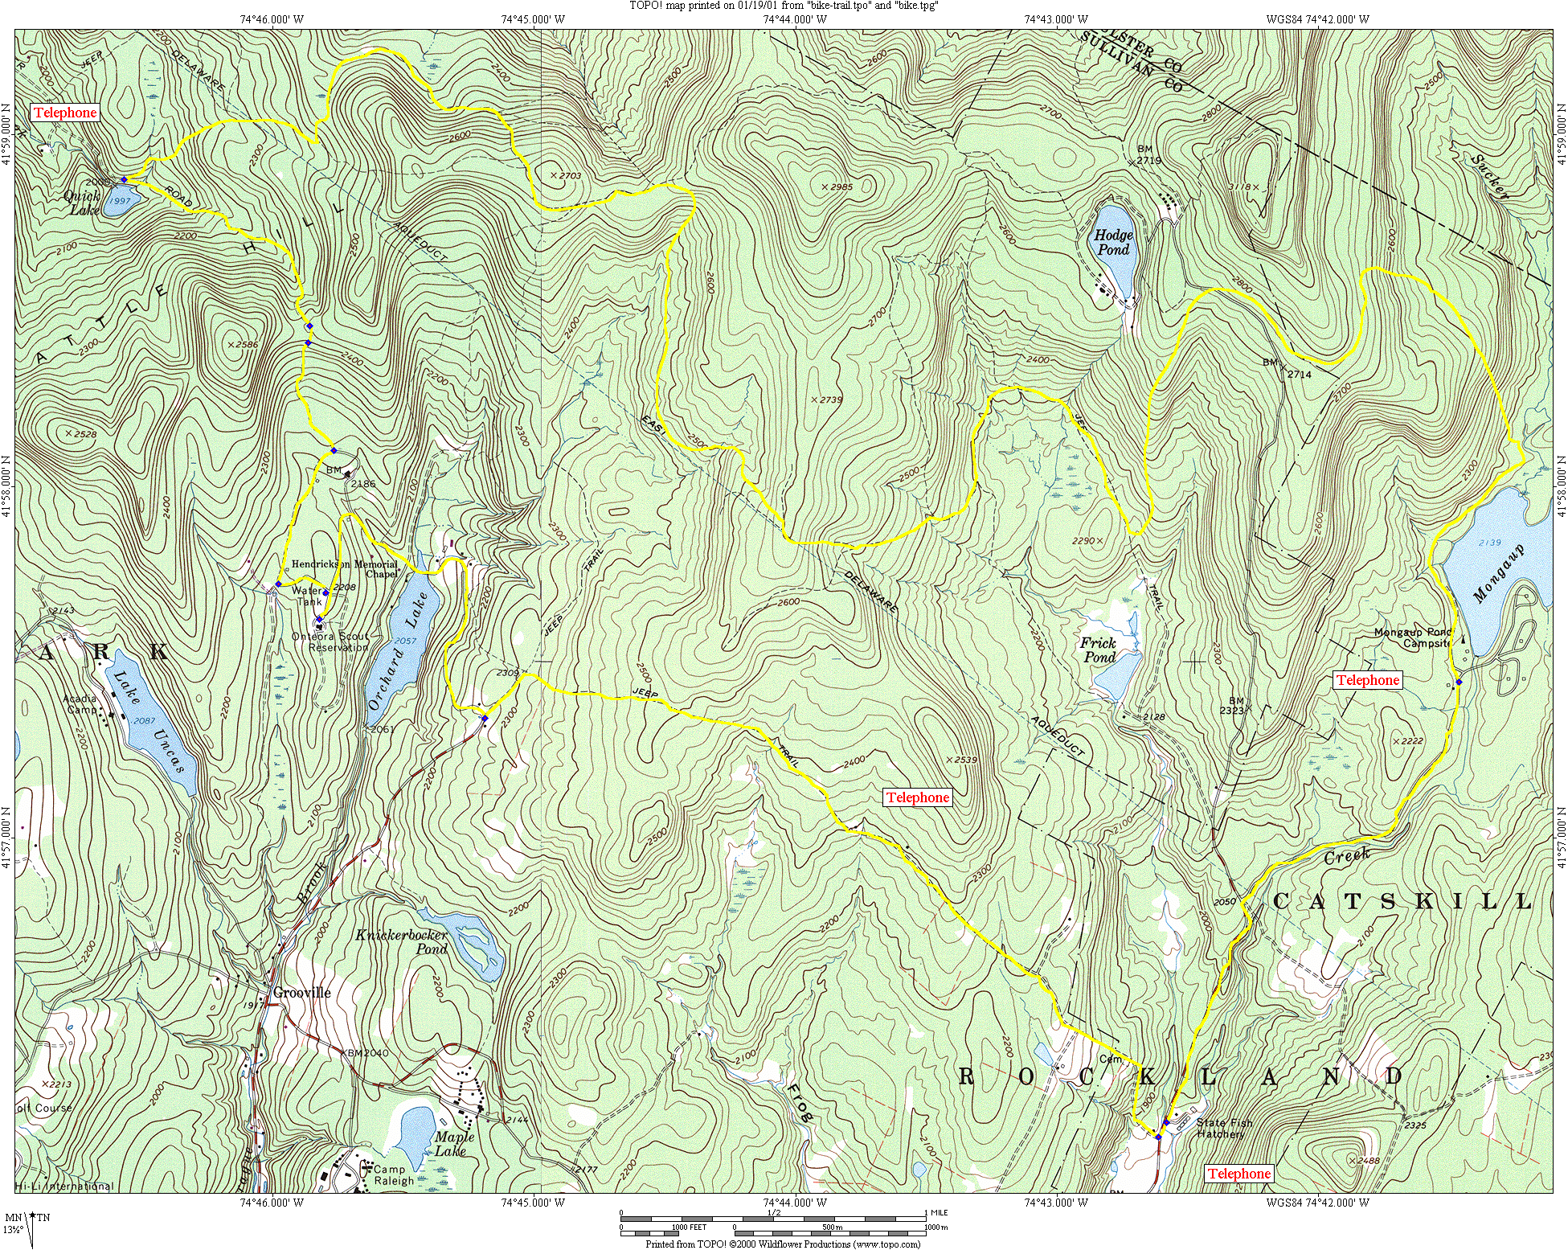

Long House Trails

The following short cut trails have been established to help provide quick access to distant sections of the camp.

Dan Beard Trail – Marker ‘D’

Trail Head: West side of the Long House

Trail: The trail is marked with a series of silver reflective square markers with a black letter ‘D’. Both ends of the trail are marked with a double vertical marker. The trail ends at the east side of the field south of the Dan Beard Shelter.

Tuscarora Trail – Marker ‘T’

Trail Head: West side of the Long House

Trail: The trail is marked with a series of silver reflective square markers with a black letter ‘T’. Both ends of the trail are marked with a double vertical marker. The trail ends opposite the Tuscarora campsite.

Lake Trail – Marker ‘L’

Trail Head: North East corner of the Long House

Trail: The trail is marked with a series of silver reflective square markers with a black letter ‘L’. Both ends of the trail are marked with a double vertical marker. The trail meets the TR Loop south of the Iroquois Site. The trail follows the road North (Left) for a few hundred feet and turns East (Right) in the field before the Lenape Site. Follow the trail downhill. The trail ends at the Lake Front Road opposite the Swimming Center Sign, which is South of the Swimming Center.

Power Line Trail – Unmarked

Trail Head: Front of the Craft Lodge

Trail: This trail is not marked. It is easiest to follow the TR Loop Road downhill from the Craft Lodge. Take the cut out to the left when the road turns to the right in front of the Navajo Site. Follow under the power lines to the rear south corner of the Trading Post.

